Chapter I
INTRODUCTION
The human body is one of the most astonishing creation and natural machine that has been studied and known by human race. The human body is incredibly complex in a way that until today there are abundant mysteries that researches are still trying to uncover specially when it comes to the way the brain perceives events and the human body responds accordingly. Some human reflexes to events are based on human nature or nurture [1]. Humans also have an outstanding ability to control their body the instant they tend to lose stability. There are numerous causes of losing stability, such as a sudden external impact force, a change in the geology of the contact surface of the ground or even a loss in balance [2].
For many years, humans have been trying to artificially redesign the multipart and composite mechanism that constitutes it. The mission is extremely dense, but lead to the design of a machine that looks like a human, behaved and adapts the environment in a way similar to that of humans. However, the current status of these designed robots, is not yet adequate and they are still far from autonomous and self-regulating as expected and desired. Yet, they are used in a diversity of fields. They have been used in the medical field for clinical support, in the educational field as instructors, in the industrial field to perform many tasks instead of humans, in the military field for search and rescue tasks or even combat and many other purposes in numerous fields [3].

Statement of the Problem
A human like structured autonomous robot that is capable of adapting to changes in an environment, takes decisions and performs tasks is called a humanoid robot. This kind of robots is currently under-study and research as scientists and engineers aim to let this robot imitate humans in the way they move, perceive events and also make decisions. They are designed to imitate the human body and its activity when humans have a large number of degrees of freedom and yet can control their movement well even if they were subject to a sudden impact force.
The increased number of degrees of freedom in a Humanoid robot must make it even more difficult to control the movement alone. The case is even taken to a higher level of difficulty if the humanoid is subject to an external impact force which yields to a loss in stability. Humans also have the ability to perceive events and sense their surrounding incredibly due the sense of awareness and consciousness they have and sensory neurons through touch. They can locate themselves in a room without seeing but retrieving information in their memory and act accordingly. They can also stabilize their posture better knowing the cause of turbulence or even the location of an external impact force on them. All these facts and capabilities are ones that the human’s body has whereas robots do not. But the Humanoid should still be designed and integrated to be able to move, perceive events and behave in a way similarly to that of humans;

Hypothesis or Key Questions
Since a humanoid robot is expected and required to behave in a way imitating that of humans’, the robot should be equipped with a design including the minimal requirement for a sense of awareness or consciousness a human has. The ability of a robot to be able to know more about the external effects on it should be improved remarkably special when it comes to external effects that lead to a loss in stability. If the robot perceives it’s surrounding better, only then it will be able to react and control its movement and posture to gain back it stability in a more educated and fed control system in spite of the increasing number of degrees of freedom which makes controlling the robot more difficult.

Proposed Solution
Humanoid robots impact complex problems in control that need to be solved using methods that vary from classical control methods since coordination and balance are continually in demand. In this thesis entitled Humanoid Stability Analysis Based on Impact Location and Intensity, a humanoid robot is going to be modeled in a virtually realistic and robust physics engine where the robot will be tested. The robot will be subject to different types of forces in different locations and intensities and the robot’s response will be observed by monitoring the parameters changing in the sensors of the motors at each joint and link. The results can also be used in a machine learning algorithm that will be trained and then tested to ameliorate and increase the robustness of the stability control algorithm as it will be able to help the robot regain stability in a more educated system. This proposed solution is a good approach to solving the stated problems as it will be reducing or in a way eliminating to use of pressure sensors or any other alternatively used sensors that are used to locate the location, intensity and type of an impact force on the robot.

Specific Objectives and Proposed Time-line
This thesis will mainly target analyzing the stability of a humanoid robot based on the location and the intensity of the impact force. The location of the impact force and its intensity will have to be extracted without the use of sensors.
Frist the humanoid will have to be rendered. The joints properties and parameters will have to be monitored and observed. When the robot is subject to an impact force, a loss in stability is expected with the joints and links moving in a certain way. The change in the robot’s posture will have to be monitored by observing and keeping record of the position of the links and the parameters of the joints. This recorded data is the expected reaction of the robot to a specific kind of force at a known location and with a predefined intensity.
To meet the main objective of this thesis, the specified objectives have to be satisfied in steps of the work after conducting a good research to know more about humanoid robots, the work that have been done, and were studies reached in the field of humanoid stability until now. The entire process will have to be planned in a function of time. The time line in figure 1 displays the expected time need to proceed in two main sectors; the work needed to be done to retrieve results and the documentation of the work in this report. The total time needed for this study to be conducted is expected to be is three quarters of a year. A good amount of time must first be allocated for research followed by the theoretical approach that is expected to be a work that will need a quarter to be done. During this time all the humanoid robot will have to be modeled. When the model is ready the motion analysis for the robot have to be done. Then the robot will have to be tested under disturbances where these impact forces will have to be evaluated with and without sensors to compare the results leaving us with a stability control algorithm which will have to be integrated at a later stage.
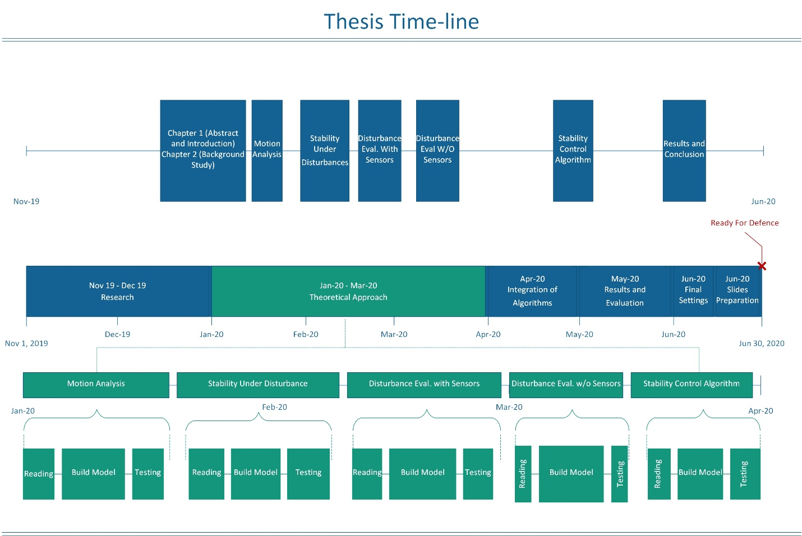
Figure 1. Tentative Time-line

Significance of this Work
Regardless the complexity of the problems, every contributing in this field counts. This thesis will definitely tackle the problem of stability of humanoid in an innovative way based the location and intensity of the impact force which is the main cause of the loss in the robot’s stability. This approach will help in increasing the sense of awareness and consciousness the robot has without having sensors covering the robot’s surface to act like an artificial skin as it has been done by a team from the Technical University of Munich in the research entitled “A Comprehensive Realization of Robot Skin: Sensors, Sensing, Control, and Applications” [4]. As proposed, monitoring the movement and the links and the parameters of the joint of the humanoid when it is subject to an impact force, will help the robot learn more about the impact forces it will be subject to by locating, evaluation, and classifying the impact force. This work will enlighten the humanoid by giving it the ability to regain its stability when lost in a more thoughtful and educated way.

